Frontend Developer Technical Assessment
Project: Responsive AI Content Generation Web Page

Overview
The goal of this assessment is to evaluate your ability to build a responsive, production-quality frontend using Next.js. A design mockup of an AI content generation web page is given below. Your task is to accurately implement this design as a fully responsive web page.
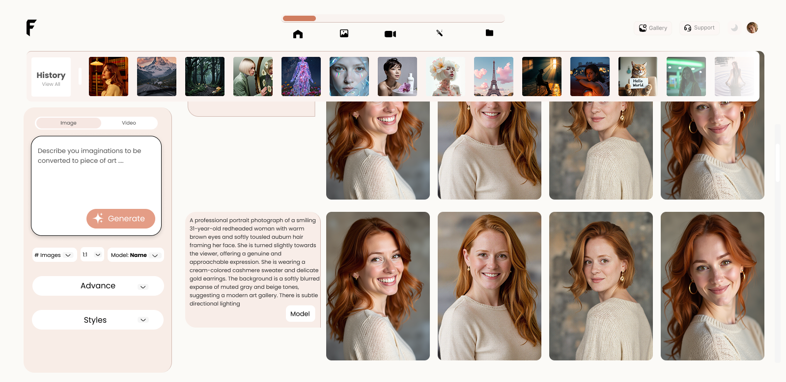

Tech Stack (Required)
- Framework: Next.js
- Language: JavaScript
- Styling: CSS Modules, Tailwind CSS
- Version Control: GitHub

Task Description

1. UI Implementation
- Convert the provided design image into a functional web page.
- Match layout, spacing, typography, and colors as closely as possible.
- Use reusable components where appropriate.

2. Responsiveness
The page must be fully responsive across:
- Mobile (320px+)
- Tablet
- Desktop
- Large screens
Ensure:
- Build a dummy API that will return images and videos for the generated content.
- No horizontal scrolling
- Proper alignment and spacing at all breakpoints
- Mobile-first or adaptive approach

Code Quality Expectations
- Clean, readable, and well-structured code
- Proper reusable component separation
- Meaningful commit messages
- Consistent naming conventions
- No unused code or assets

Performance & Best Practices
- Optimize images using Next.js (next/image)
- Use semantic HTML
- Ensure accessibility basics (labels, alt text, readable contrast)
- Avoid unnecessary re-renders

GitHub Submission Instructions
- Create a private GitHub repository
- Push your completed project to the repository
- Share the repository link once completed
Points System
Other then points mentioned above, there are heavy points on
Visual design
Attention to deal and use of negative space
Bonus points: Second submission of a unique design, with your own creative direction of what an image generation page should look like.

Optional (Bonus Points)
- Pixel-perfect implementation
- Self coded without AI Assistance
- Dark mode support
- Smooth transitions/animations
- Well-written README explaining structure and decisions

Deliverables
- GitHub repository link (private)
- Instructions to run the project locally
- Confirmation that responsiveness was tested across devices (screenshots)

Best of Luck

